**Deployment of .Net core web application in Paas deployment.**

Step:1 Create .net web application name “web app .net”

Step:2 Clone the code to Github

<https://github.com/KDHANAPR/web-3456.net.git>

Step:3 In the Solution Explorer, Give a right click on the project “webapp123”

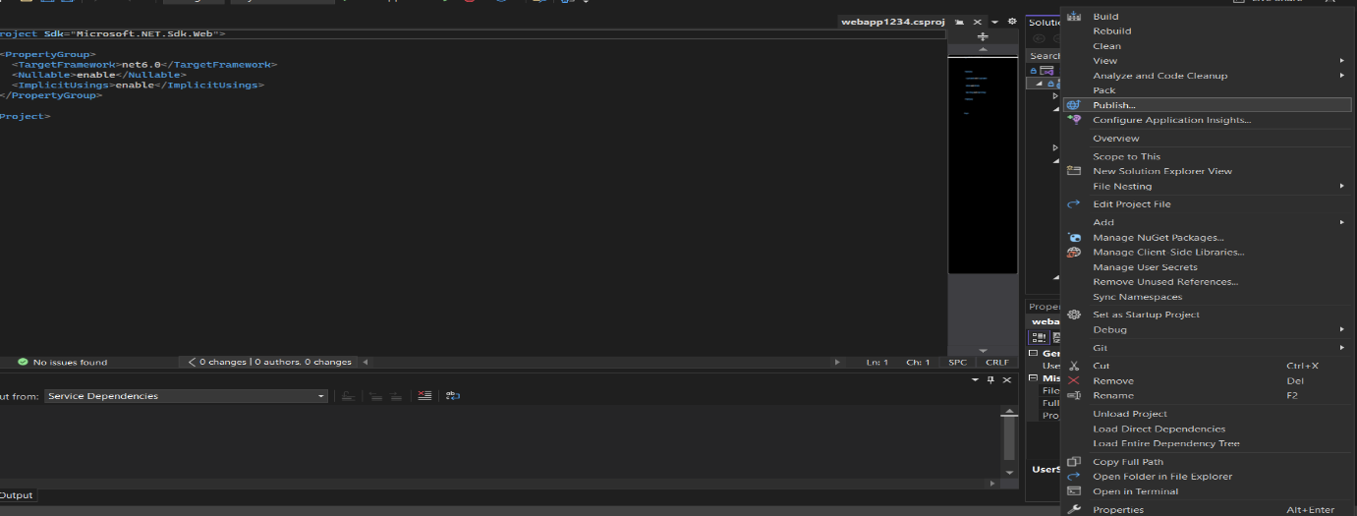

Step:4 Now select the publish target to azure cloud and click on Next.

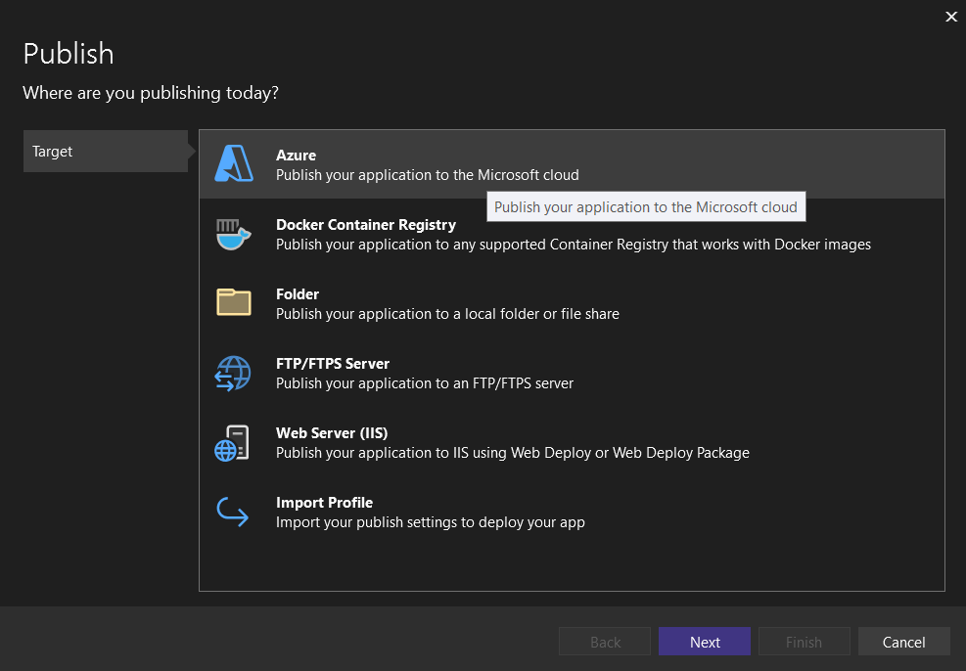

Step:5 If you have a existing App Services select from that or you can create a new app service and click on finish button.

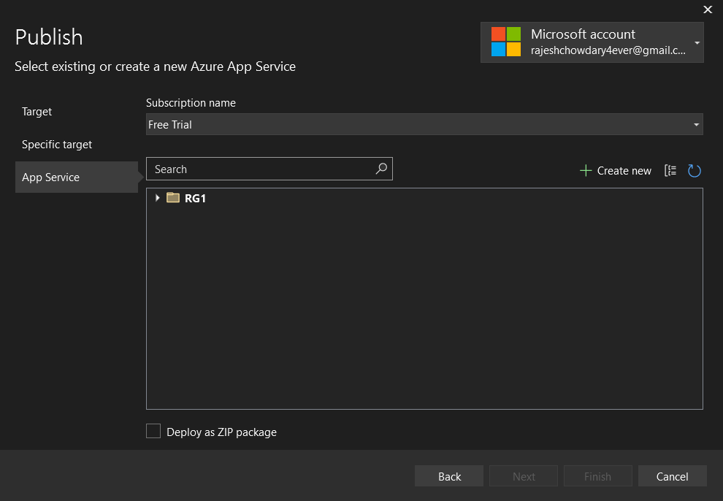

Step:5 Now you are all set to publish the web app Click on the publish button



Step:6 Now successfully your Web application is deployed in Azure

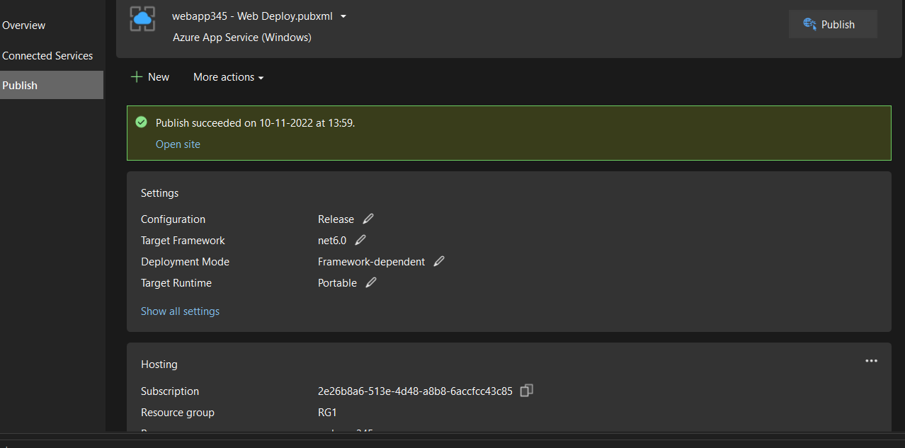

Step:7 Check the deployment link from app service in azure portal or in the Hosting details in Visual Studio and browse it

Deployment link: [https://webapp345.azurewebsites.net](https://webapp345.azurewebsites.net/)

